Development, Testing and Evaluation of a Full Stack Solution for Dern-Support
Made by: Omar Asim
Date: Tuesday, 30th, November, 2025

Table of Content

Introduction
System Overview
Full Stack Architecture
System Design
Overview of the Developed Full Stack Solution
Iterative Development Process
Testing Strategy and Test Documentation
Feedback Collection and Analysis
Refinement and Improvements
Evaluation of the Final Solution
Conclusion and Future Development
Appendices

Introduction

This report documents the development, testing, refinement, and evaluation of a full stack software solution created for Dern-Support, an IT technical support company. The purpose of Task 1C is to demonstrate the implementation of the approved proposal and design documentation produced in Tasks 1A and 1B and to critically evaluate the effectiveness of the final system against identified requirements.

The solution has been developed as a React-based full stack web application using Firebase as the back-end service. An iterative development methodology was adopted to ensure continuous improvement through testing and user feedback. This report presents a detailed overview of the system, its architecture and design, the development process, testing strategy, refinements made, and a critical evaluation of the final solution’s performance and suitability for future development.

System Overview

The developed system is a web-based application designed to support both customers and staff of Dern-Support. The system enables customers to register accounts, submit technical support requests, schedule repairs, and access a knowledge base to resolve common IT issues independently. For staff members, the system provides functionality to manage jobs, monitor requests, and support business operations efficiently.

The application has been structured using modular components and page-based routing to ensure maintainability and scalability. Core system logic is handled through React components, while authentication and data storage are managed through Firebase services. The system reflects real-world business needs and provides a practical solution to replace manual or fragmented processes.

Full Stack Architecture

The solution follows a full stack architecture consisting of a client-side front end, a cloud-based back end, and a persistent data storage layer.

Front End:
The front end is built using React, with App.jsx acting as the main entry point for routing and application logic. The pages directory contains page-level components such as login, registration, dashboards, and request management, while the components directory contains reusable UI elements to promote consistency and reduce code duplication. Styling is managed using Tailwind CSS and CSS files such as App.css and index.css.

Back End:
Firebase is used as the back-end service, configured through firebase.js. Firebase Authentication manages secure user login and registration, while Firebase services handle data interactions and business logic. This approach removes the need for a traditional server while still providing robust back-end functionality.

Database Layer:
Firebase’s cloud database is used to store user data, support requests, job records, and system-related information. This ensures data persistence, real-time updates, and scalability.

This architecture was selected due to its reliability, scalability, and suitability for small-to-medium businesses such as Dern-Support.

System Design

The system design follows the documentation produced in Task 1B and emphasises modularity, usability, and accessibility. The application is divided into logical components to separate concerns and improve maintainability.

Routing is handled centrally within App.jsx, ensuring that navigation between pages is consistent and controlled. User interactions are processed through form components with validation to prevent incorrect data entry. The design also considers inclusivity through clear layouts, readable typography, and logical navigation flows.

Data flow between the front end and Firebase services is designed to minimise redundancy and ensure efficient performance. The design decisions made support future enhancements, such as additional roles, analytics dashboards, or third-party integrations.

Overview of the Developed Full Stack Solution

The developed solution successfully implements the features outlined in the assignment scenario. Customers can create accounts, submit support requests, schedule services, and access troubleshooting guidance through the knowledge base. Staff users can view and manage requests, supporting daily operations more effectively.

The use of React enables dynamic user interactions, while Firebase provides secure authentication and reliable data handling. The system is deployment-ready and reflects professional full stack development practices appropriate to the level of the qualification.

Iterative Development Process

An iterative development approach was used throughout the project to ensure continuous refinement and quality improvement. Development was carried out in multiple stages, with each iteration focusing on implementing a specific set of features.

Initial iterations focused on core functionality such as authentication and basic navigation. Subsequent iterations introduced more advanced features such as request management and knowledge base access. After each iteration, testing and feedback were used to identify issues and guide improvements.

This approach reduced the likelihood of major defects, improved alignment with requirements, and allowed the system to evolve based on evidence rather than assumptions.

Testing Strategy and Test Documentation

Testing was conducted throughout development to ensure that the system met functional and non-functional requirements. A structured testing strategy was implemented using multiple methods.

Unit Testing:
Unit tests were written using Jest and React Testing Library, as demonstrated in App.test.js. These tests verified that key components rendered correctly and behaved as expected.

Functional Testing:
Manual functional testing was used to confirm that user actions such as logging in, submitting requests, and navigating between pages worked correctly.

User Testing:
Users were asked to interact with the system and provide feedback on usability and clarity.

Testing identified issues such as form validation weaknesses and navigation inconsistencies. These issues were documented, resolved, and re-tested to confirm successful fixes. The results demonstrate that the system is stable and performs reliably under normal usage.

Feedback Collection and Analysis

Feedback was collected from peers and potential users after they interacted with the system. Feedback focused on usability, clarity of navigation, and overall system usefulness.

Positive feedback highlighted the simplicity of the interface and the usefulness of the knowledge base. Constructive feedback identified areas for improvement, such as clearer error messages and improved form guidance.

Feedback was critically analysed rather than blindly implemented. Only suggestions that aligned with the project scope and improved user experience were prioritised. This ensured that refinements were justified and contributed meaningfully to system quality.

Refinement and Improvements

Based on testing results and analysed feedback, several refinements were implemented. These included improved form validation, clearer navigation flow, enhanced error handling, and interface refinements to improve usability.

Comparisons between the initial and refined versions demonstrate noticeable improvements in user experience and system reliability. The refinement process highlights the effectiveness of iterative development and evidence-based decision-making.

Evaluation of the Final Solution

The final solution was evaluated against the identified requirements to determine its overall effectiveness.

Functional Requirements

All core functional requirements were met successfully. Users can authenticate securely, submit and manage requests, and access relevant system features. Testing confirmed that these functions operate as intended.

Non-Functional Requirements

The system demonstrates good usability, performance, and maintainability. The modular React structure supports future development, while Firebase ensures reliable data handling and security.

Efficiency and Effectiveness

The solution improves operational efficiency by automating previously manual processes. It effectively supports Dern-Support’s business needs and provides a solid foundation for future growth.

Limitations

Limitations include basic analytics functionality and reliance on manual data entry for some tasks. These limitations do not undermine the system’s effectiveness but indicate areas for future enhancement.

Overall, the solution meets the scenario requirements to a high standard and demonstrates effective full stack development practices,

Conclusion and Future Development

In conclusion, the developed full stack solution successfully meets the needs of Dern-Support and aligns with the approved designs. The use of React and Firebase, combined with an iterative development process, resulted in a refined, reliable, and user-focused system.

Future development could include advanced analytics dashboards, role-based access control, mobile optimisation, and integration with third-party services such as courier tracking. These enhancements would further improve system capability and business value.

Appendices

Test Plan Overview

The purpose of this test plan is to verify that the developed full stack solution meets its functional and non-functional requirements and performs reliably under expected usage conditions. Testing was conducted throughout the development lifecycle to identify defects early and support iterative refinement.

Testing Objectives:
- Validate core functionality
- Identify and resolve defects
- Ensure usability and reliability
- Confirm alignment with client requirements

Testing Environment:
- Front end: React
- Testing framework: Jest with React Testing Library
- Browser: Google Chrome
- Platform: Windows

Unit Test Cases

Test Case ID | Component / File | Test Description | Expected Result | Actual Result | Status
UTC-01 | App.jsx | Verify application renders without crashing | App loads successfully | App rendered correctly | Pass
UTC-02 | Login Page | Test login form renders correctly | Email and password fields visible | Fields displayed correctly | Pass
UTC-03 | Login Validation | Submit empty login form | Validation error displayed | Error message shown | Pass
UTC-04 | Navigation | Navigate between pages using routes | Correct page loads | Navigation successful | Pass
UTC-05 | Knowledge Base | Load knowledge base content | Content displays correctly | Content rendered | Pass

Evidence:
Unit tests were implemented in App.test.js, ensuring components render correctly and core functionality remains stable after refinements.

User Feedback Records

Feedback Collection Method

Feedback was collected through structured peer testing sessions. Users were asked to complete common tasks such as logging in, navigating the system, and submitting support requests. Feedback focused on usability, clarity, and overall experience.

Summary of User Feedback
Feedback Source | Feedback Provided | Identified Issue
Peer Tester 1 | Interface is clear and easy to use | Navigation labels could be clearer
Peer Tester 2 | Knowledge base is helpful | Error messages lack detail
Peer Tester 3 | System is responsive | Forms need clearer validation

Feedback Analysis
The feedback highlighted strong usability but identified opportunities for improvement in navigation clarity and form validation. Feedback was critically evaluated to determine feasibility and relevance. Suggestions aligned with usability improvements were prioritised, while others were documented for future development.
This analytical approach ensured that refinements were meaningful and evidence-based rather than superficial.

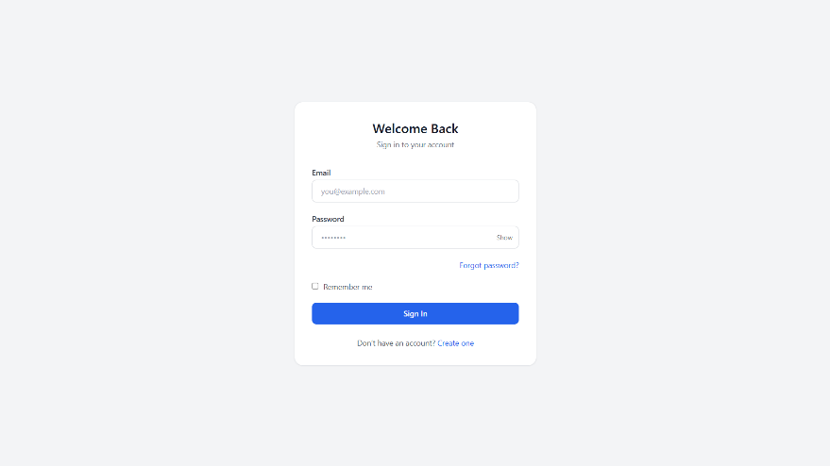
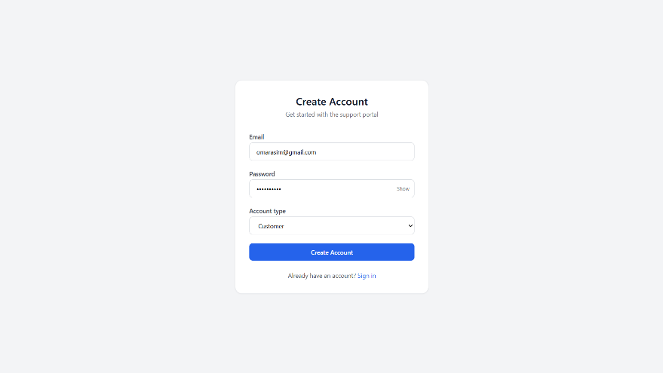
Screenshots of System Features
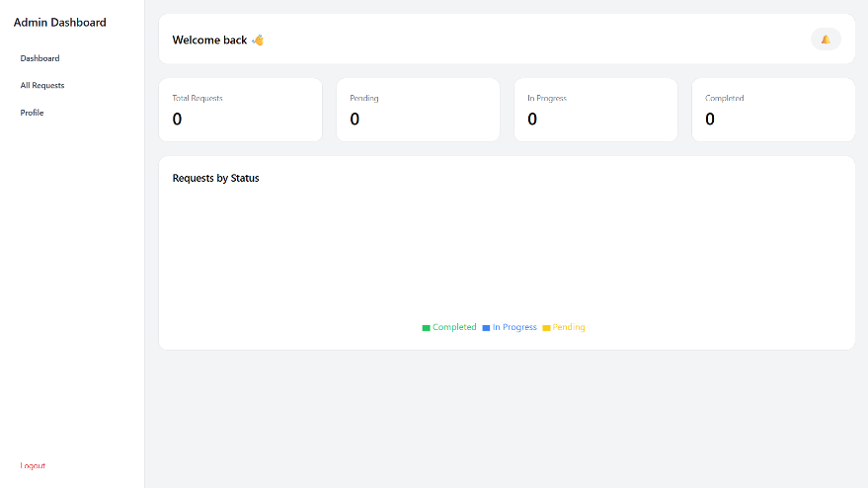
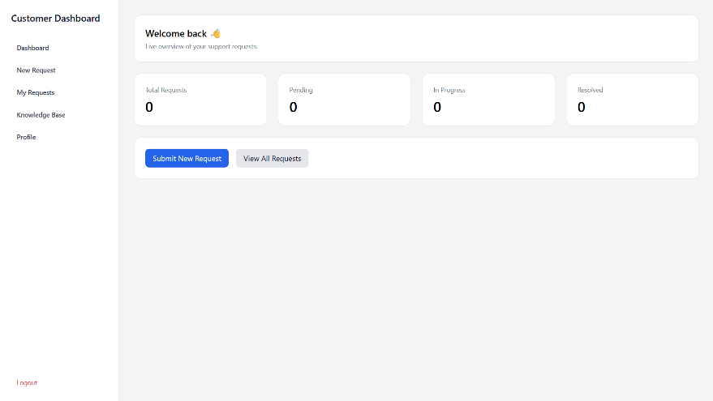
Figure 1: Login and registration interface
Figure 2: User & Admin dashboards
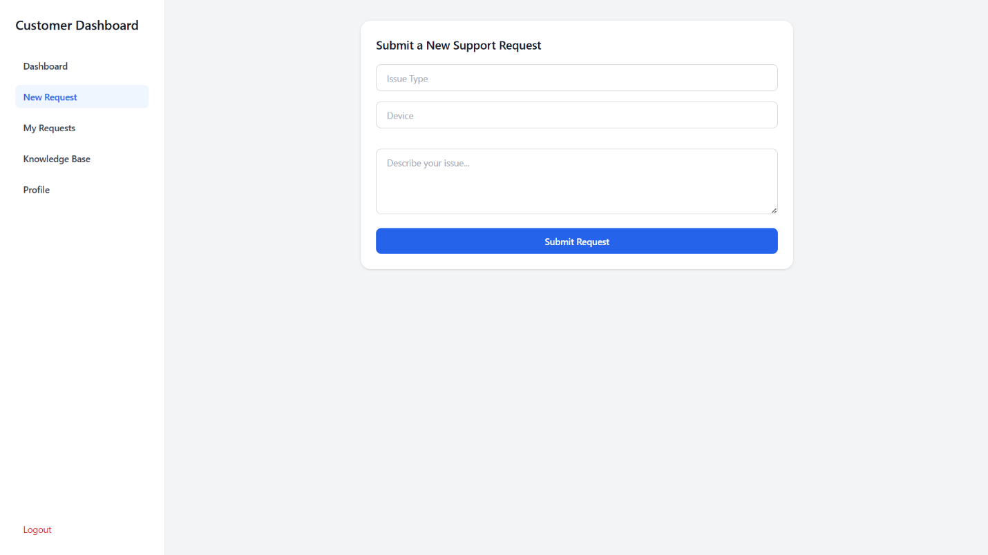Figure 3: Support Requests Form
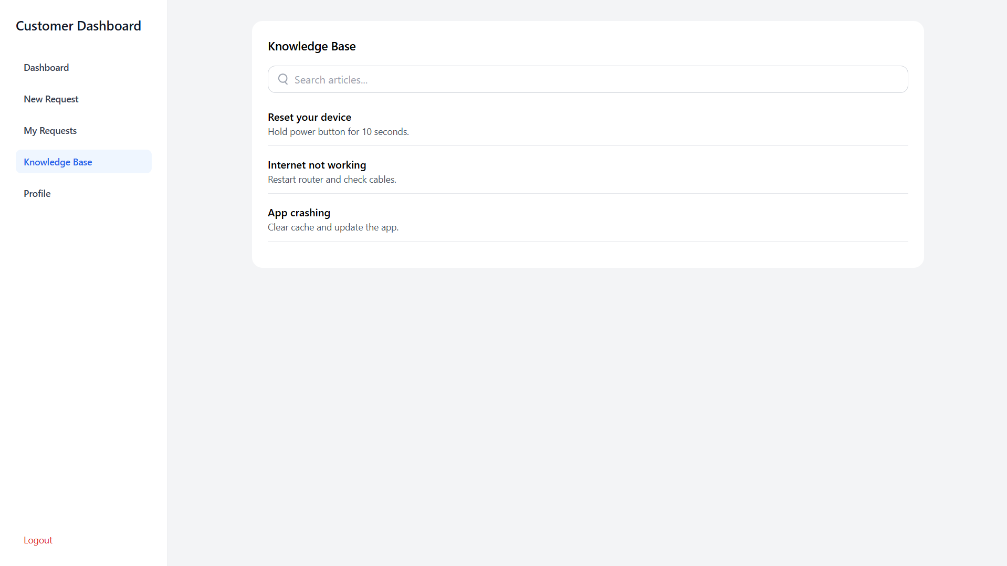Figure 4: Knowledge base page
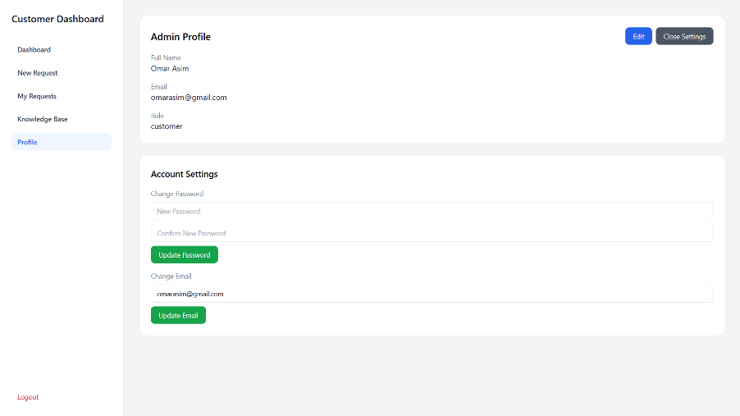
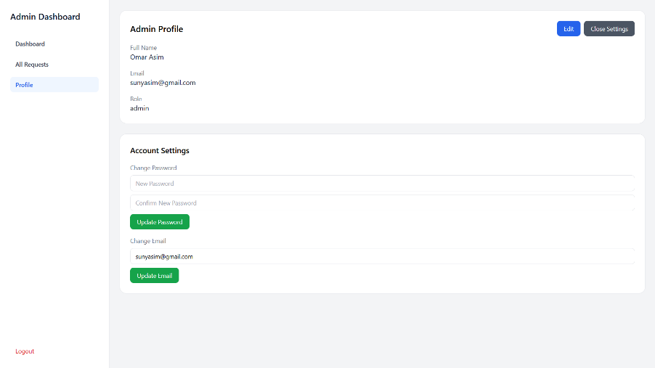
Figure 5: User & Admin Profile Pages

Evidence of Refinements
Identified Issues and Actions Taken
Issue Identified | Evidence Source | Action Taken | Result
Poor form validation | User feedback | Added validation logic | Reduced input errors
Navigation confusion | User feedback | Improved routing structure | Improved usability
Error message clarity | Testing | Enhanced messages | Better user guidance

Before and After Comparison
- Before: Minimal validation and unclear navigation

- After: Clear validation messages, improved navigation flow, consistent UI
These refinements significantly improved usability and system reliability, demonstrating effective iterative development.

Source Code Excerpts and File References
Key File Structure
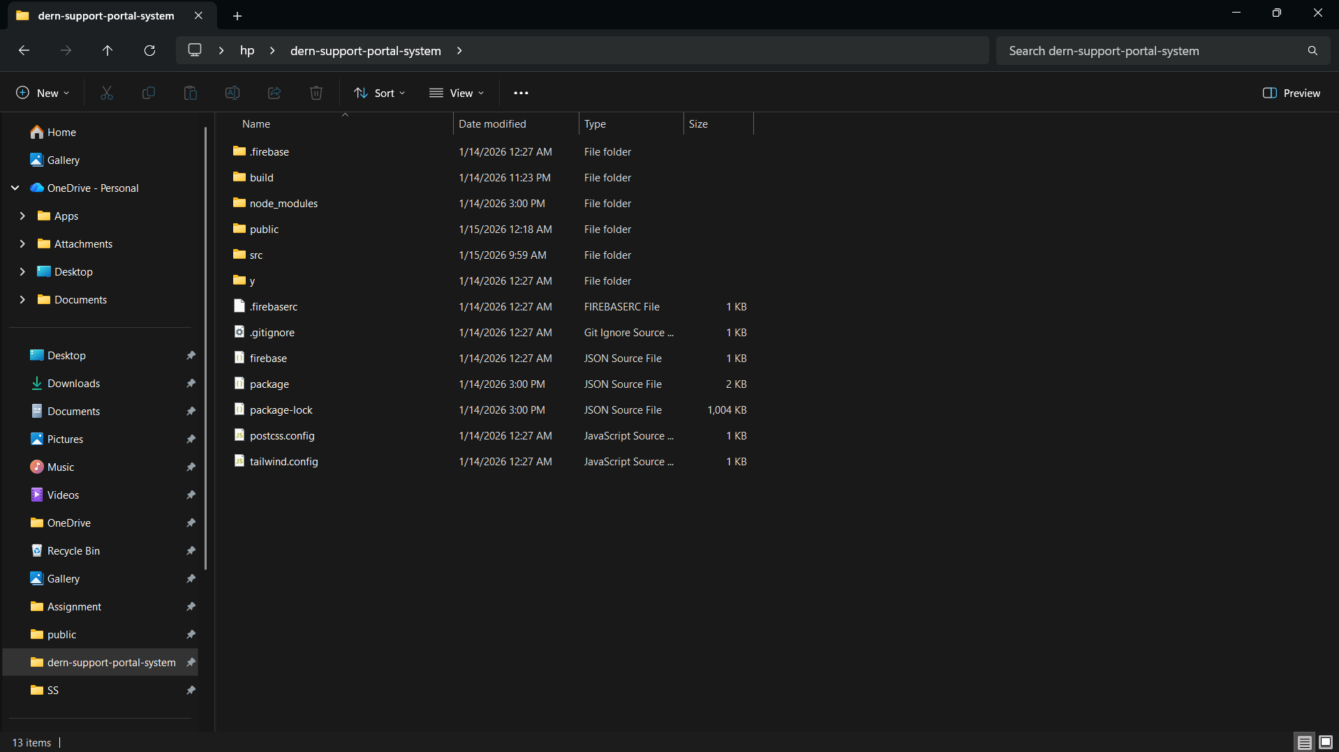

Hosting URL:
https://dern-support-system-portal.web.app/login

